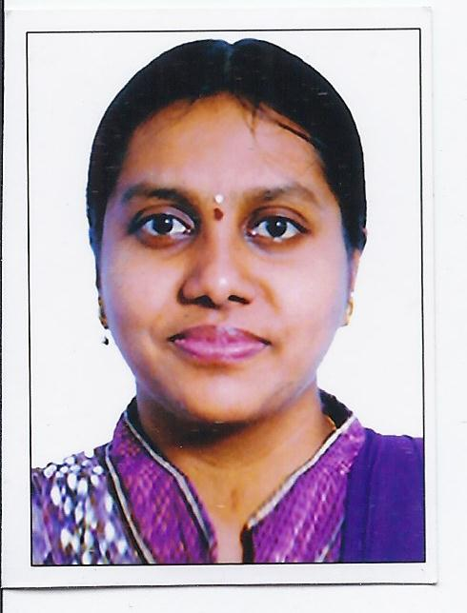

PERNI PAVANI

OBJECTIVE

With my abilities in analytical thinking and innovative skills along with a keen interest in developing products, I believe that my approach will be beneficial to the organization to a great extent.

CONTACT INFORMATION

Mobile 7382747146

Email perni.pavani@gmail.com

Address 8-3-825/5/5/3, Sri Srinivasa
Nilayam, Yellareddyguda,
Hyderabad-500073

WEB PRESENCE


LinkedIn:
https://www.linkedin.com/in/perni-pavani-962345ab

WORK EXPERIENCE

2015-2017 Intelenet Global Services, IT Analyst

- I am a member of the data-processing team.
- I am responsible for using source data to create, update or modify Google digital map databases inside Europe and worldwide.
- Our team works on products that are delivered to the customer directly after creation.

EDUCATION

2019 Master Of Science Information Technology

IIIT Hyderabad

2013 BTECH Electrical and Electronics Engineering

SASTRA University

2009 Intermediate

Sasi Junior College

2007 Class X
Sasi High School

AWARDS

2016 Star Performer of the year while working for
Intelenet Global Services in Google Ground Truth

SKILLS

C, Java, Python, HTML, CSS, Java Script, Django
SQL Database
Algorithms and Data structures
Google Android

ACADEMIC PROJECTS

Project Name: DayBreak Music Player

Role: Team Leader Duration: 1 month

Technologies Used: Google Android, Java

Description: DayBreak Music player is application software based on Google Android. The purpose of this project is to develop a player which can play the mainstream music file format. To browse and query the storage space as well as operation of adding, deleting, and playing can be realized. Meanwhile, this software can play, pause and select songs with play/pause button and next button according to users’ requirement as well as setup songs’ order etc.

Project Name: Fast Switching Technique

Role: Team member Duration: 6 months

Technologies Used: Micro-Controller encoding, Simulation software

Description: Developed a fast switching technique using timers and encoded micro controllers to perform PDC analysis on the transformer to determine the life of a transformer. This improvisation helps to obtain accurate readings. Designed a successful circuit and ran the software simulation before building the physical model.

EXTRA-CURRICULAR ACTIVITIES

- Project Score: Member of Quality Team. A social initiative to adopt a village and educate them on basic amenities and technologies.
- Microsoft Dream Spark Yatra: Learned about finer nuances of Microsoft Office suite and other technologies developed by Microsoft.

HOBBIES

Reading books, Photography

